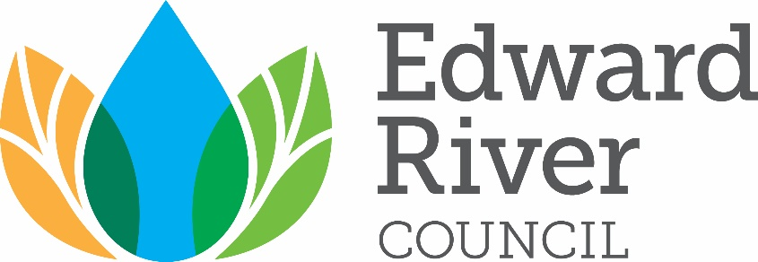

Edward River Council
Australia Day Awards 2021

Nomination Pack

Citizen of the Year
Senior Sports Award
Junior Sports Award
Arts & Culture Award
Community Event or Initiative of the Year

About the Awards
The Edward River Council Australia Day Awards celebrate the achievement and contribution of individuals and community organisations in our region. Our Australia Day Awards are the highest honour Council can bestow to publicly acknowledge the many local heroes within our community, whose dedication and contributions may otherwise go unnoticed.

Australia Day Award recipients are determined by Council’s Australia Day Awards Assessment Panel. Award recipients are announced at Edward River Council’s Australia Day celebrations, held annually on 26 January, and presented with an Australia Day gift and certificate by the Mayor of Edward River Council.

Nomination Assessment
All nominations are assessed and determined by Edward River Council’s Australia Committee. This Committee comprises:
- The Mayor or his/her delegate;
- The General Manager or his/her delegate;
- Two (2) Councillor representatives; and
- Two (2) community representatives appointed by Council.

How to Complete Your Nomination
Complete the selection criteria for your Award category. If required, you may provide any further details in a separate document as to why your Nominee should receive the Edward River Council Australia Day Award for which they are nominated.

Nominations that do not meet the eligibility and selection criteria or are not submitted on the official nomination form will not be considered. Late nominations are also considered ineligible.

You may also:
- Enclose clear copies of any newspaper or magazine articles about the Nominee or their achievements; and/or
- List any other awards received.

Please use BLOCK LETTERS when completing your nomination.

Submitting Your Nomination
Completed nominations should be returned to Edward River Council by close of business Friday, 4 December 2020. Completed nominations can be submitted by:
Email: council@edwardriver.nsw.gov.au

Post: Australia Day Awards Assessment Panel
Edward River Council
PO Box 270
DENILIQUIN NSW 2710

Further Information
For more information regarding Edward River Council’s Australia Day Awards, please contact the Office of the General Manager on (03) 5898 3000 or via email at council@edwardriver.nsw.gov.au.
Details of Nominator – Person making the nomination
Name
Address
Email
Phone |  | Mobile

Details of Nominee – Person being nominated for an Award
Name
Date of Birth* |  | Occupation
Address
Email
Phone |  | Mobile
* Date of Birth only required for sports award.

Citizen of the Year
Senior Sports Award
Junior Sports Award
Arts & Culture Award
Community Event or Initiative of the Year

Eligibility Requirements
- Nominees must be Australian Citizens and residents of the Edward River Council Local Government Area (LGA) at the time of their nomination; Award must be for work performed principally in the Edward River Council LGA; Nominees must meet the age criteria, where applicable; Nominees must not nominate themselves.

Award Categories

Citizen of the Year Recognising a resident aged 26 years or older on 26 January 2021 who has made a noteworthy contribution to the betterment of the Edward River region and/or given outstanding service to the local community in the past 12 months or over a number of years.

Senior Sports Award Recognising a resident aged 26 years or older on 26 January 2020 who has demonstrated an outstanding record of achievement in sport or through their involvement as an administrator, official or coach, or who has made a significant contribution to the growth, development and/or increased participation of their sport within the Edward River region.

Junior Sports Award Recognising a resident aged 25 years or younger on 26 January 2020 who has demonstrated an outstanding record of achievement in sport or through their involvement as an administrator, official or coach, or who has made a significant contribution to the growth, development and/or increased participation of their sport within the Edward River region.

Arts and Culture Award Recognising a resident who has made a noteworthy contribution to the cultural life of the Edward River region or an outstanding achievement in a cultural activity, including creating partnerships to benefit the arts and culture of the community and raising awareness of the value of the arts in our community.

Community Event or Initiative Recognising a group or organisation of greater than four (4) or
of the Year more people who, over the past 12 months, have made a noteworthy contribution to the Edward River region through conducting a successful project, event, activity or initiative which has brought recognition and credit to the community through a cultural, economic, environmental or sporting achievement within the Edward River region.

Summary of Nominee’s Achievements
Please provide details of how the Nominee has made a significant contribution to the community over the past 12 months, including activities undertaken, positions held, and a statement about why you believe the Nominee is deserving of recognition. As a guide, you should consider the following:
- In what role or area has the Nominee excelled?
- How has the Nominee demonstrated service worthy of recognition?
- How has the Nominee’s contribution impacted on a locality or group or the community-at-large?
- What makes the Nominee stand out from others?

______________________________________________________________________________
______________________________________________________________________________
______________________________________________________________________________
______________________________________________________________________________
______________________________________________________________________________
______________________________________________________________________________
______________________________________________________________________________
______________________________________________________________________________
______________________________________________________________________________
______________________________________________________________________________
______________________________________________________________________________
______________________________________________________________________________
______________________________________________________________________________
______________________________________________________________________________
______________________________________________________________________________
______________________________________________________________________________
______________________________________________________________________________
______________________________________________________________________________

Referee – Please provide the details of another person who may be contacted for further information about the Nominee.
Name
Address
Email
Phone |  |  | Mobile
Selection Criteria – All Nominations will be assessed against the below selection criteria weighting matrix
Question |  | Criteria |  |  | Points
Contribution/s to the community |  | Demonstrates contributions to the broader community |  |  | 5
 |  | Undertakes activities which have short- and long-term benefits for others |  |  | 5
 |  | Undertakes activities that promote the welfare and wellbeing of the community |  |  | 5
Other significant contribution/s and achievements |  |  |  |  | 10
Demonstrated excellence |  |  |  |  | 5
Any other relevant background |  |  |  |  | 5

Privacy Notification
Edward River Council acknowledges and respects the privacy of individuals. Personal information collected by Council for Australia Day Awards may be published in local circulating newspapers and on local radio and announced at public events. Personal information you provide to Council is protected by the Privacy and Personal Information Protection Act 1998. Council will not disclose your information to a third party unless required by law. The information requested on this form is being collected by Edward River Council for use in the awarding of the 2020 Edward River Council Australia Day Awards.

The information you provided on this form will be kept on file and made available only to members of the Edward River Council Australia Day Awards Selection Panel. Participants in the Australia Day Awards may have their image recorded for use in various forms of media, reports and/or presentations, for which there will be no form of compensation. Your submission of this form will constitute your consent to the collection and use of this information as described.

