|  |
| --- |
| **BUDGET INFORMATION AND FORM** |

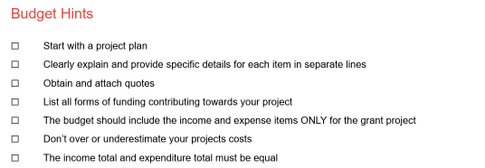**Budget Hints**

**Income vs Expenses:**

**EXPENSES**

**Cost of all the items required for the project**

**INCOME**

**All the funding that will contribute to the project**

**In-Kind & Voluntary Support:**

In-kind and voluntary support are contributions to a project other than cash money. Many projects are assisted through different groups within the community. Some support can be in-kind in nature like voluntary labour or donated goods and services.

If your project is supported by volunteers, you should list the roles of these volunteers and the number of hours they contribute to your project.

Volunteer hours are calculated at the following rates:

|  |  |  |
| --- | --- | --- |
| **Labour Type** | **Hourly Rate** | **Examples** |
| Volunteer general labour | $20 | Demolition of club rooms  Preparation works for laying a concrete slab  General clean up following completion of works |
| Specialist labour & support | Up to $45* | Qualified tradesman  Architect  Engineer |

**How to Calculate your In-Kind & Voluntary Contribution:**

|  |  |  |  |  |
| --- | --- | --- | --- | --- |
| **Task to be completed** | **Name/s of those who will undertake task** | **Number of hours** | **Rate per Hour** | **Total Cost** |
| Demolish existing kitchen | Joe Bloggs  John Smith | 5  5 | $20  $20 | $100  $100 |
|  | **TOTAL** | **$200.00** | | |

**Application Budget Form:**

|  |  |  |  |  |  |  |  |
| --- | --- | --- | --- | --- | --- | --- | --- |
| **Financial and In-Kind Contributions** | | | | | | | |
| **Are there any contributions?**  Please detail both In-Kind and Financial Contributions below. | | | | | | | |
|  | In-kind (volunteer labour) contribution | |  | | Financial (cash) contribution | | |
| **Will funding be sought from other sources?**  If funding is sources from other sources, please show as income below. | | | | | | | |
|  | Yes | |  | | No | | |
| **Details of Voluntary Labour** | | | | | | | |
| **Task to be completed** | | **Name/s or number of people who will be completing tasks** | | **No. of Hours** | | **Rate per Hour** | **Total Cost** |
|  | |  | |  | |  |  |
|  | |  | |  | |  |  |
|  | |  | |  | |  |  |
|  | |  | |  | |  |  |
|  | |  | |  | |  |  |
|  | |  | |  | |  |  |
|  | | **TOTAL** | |  | | $ | $ |

|  |  |  |  |
| --- | --- | --- | --- |
| **Income** | | **Expense** | |
|  | $ |  | $ |
|  | $ |  | $ |
|  | $ |  | $ |
|  | $ |  | $ |
|  | $ |  | $ |
|  | $ |  | $ |
|  | $ |  | $ |
| **Total Income** | **$** | **Total Expense** | **$** |